**Methodology Document**

* **Data Inspection:**

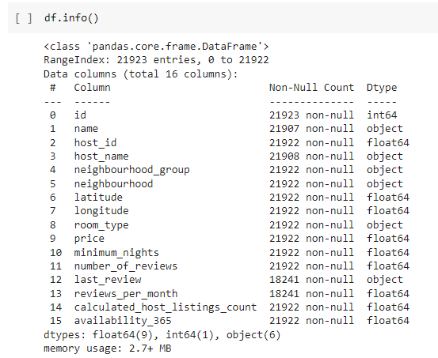

* Checked the columns & their data types along with non-null entries.
* Inspected the outliers in the data.
* The entire EDA was done with the help of Python.
* **Exploratory Data Analysis:**
* Analyzed the data in different columns such as price, number of reviews, reviews per month, room type, neighborhood, neighborhood group, minimum nights.
* **Visualization using Tableau:**

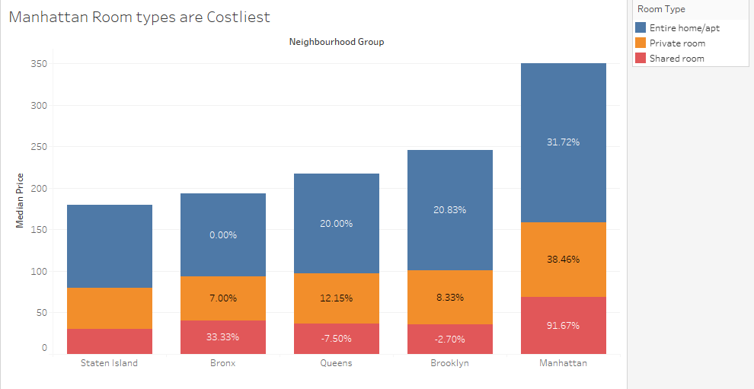

* Calculated the Percentage difference of the median price across the table to understand the difference in the median price of all the neighborhood groups.

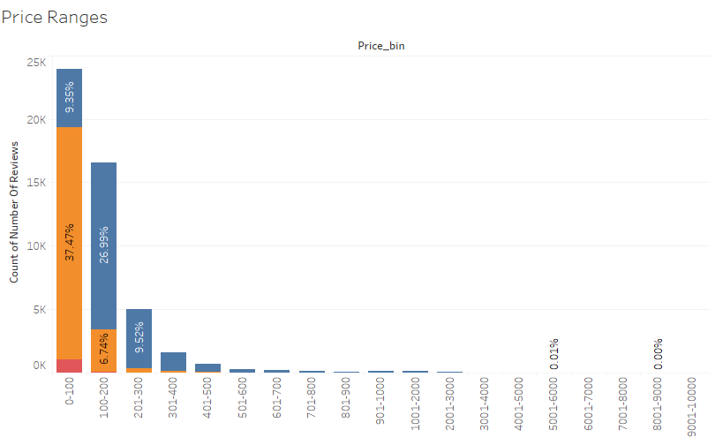

* Created a calculated field 'Price_range_bin' for binning the prices into various

Buckets.

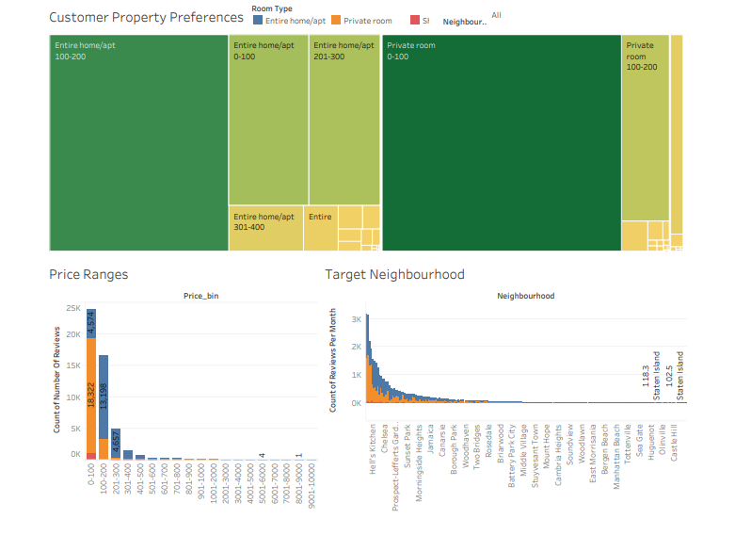

* Created a separate dashboard to gather insights about the customer preferences with respect to Properties available, Price range, and neighborhoods.

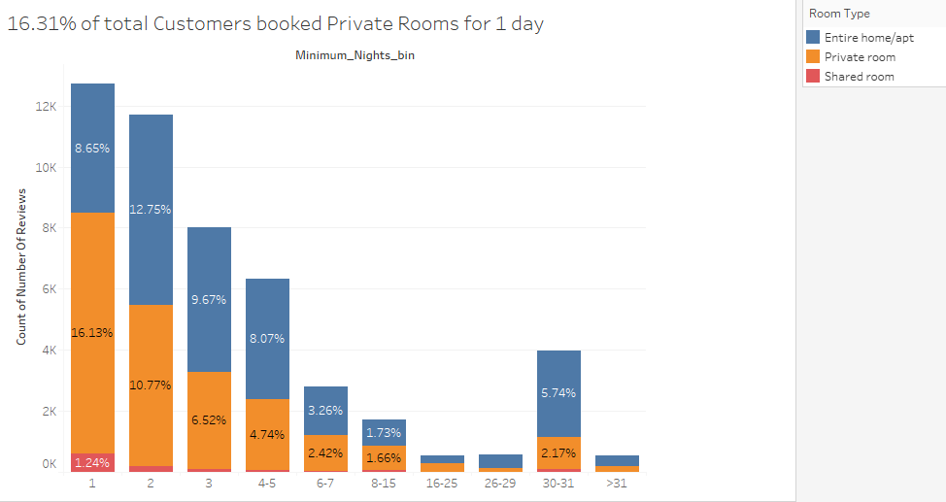

* Created a calculated field 'Minimum_Nights_bin' for binning the number of booking days into various Buckets.

**Note:** Final recommendations and inferences have been mentioned in the presentations.